Practical File of **DBMS**

Submitted to Amity University Uttar Pradesh

In partial fulfilment of the requirements for the award of the degree of Bachelor of Technology in Computer Science and Engineering by

Harmanjot Singh

DEPARTMENT OF COMPUTER SCIENCE AND ENGINEERING AMITY SCHOOL OF ENGINEERING AND TECHNOLOGY AMITY UNIVERSITY UTTAR PRADESH

**INDEX**

|  |  |  |  |  |  |  |
| --- | --- | --- | --- | --- | --- | --- |
| **S.NO.** | **Name of Experiment** | **Page** | **Date Assigned** | **Date Performed** | **Remarks** | **Sign of Faculty** |
| **1** | **To implement DDL commands** | **3-7** | **20.07.21** | **20.07.21** |  |  |
| **2** | **To implement DML commands** | **7-13** | **27.70.21** | **27.70.21** |  |  |
| **3** | **To implement SQL commands using constraints and keys** | **13-29** | **03.08.21** | **03.08.21** |  |  |
| **4** | **To implement SQL commands using aggregate functions** | **29-37** | **10.08.21** | **10.08.21** |  |  |
| **5** | **To implement SQL commands using joins and HAVING clause** | **37-42** | **24.08.21** | **24.08.21** |  |  |
| **6** | **Assignment-1** | **42-49** | **07.09.21** | **07.09.21** |  |  |
| **7** | **Assignment-2** | **49-55** | **28.09.21** | **28.09.21** |  |  |
| **8** | **Assignment-3** | **56-64** | **05.10.21** | **05.10.21** |  |  |
| **9** | **To implement views in SQL** | **65-67** | **12.10.21** | **12.10.21** |  |  |
| **10** | **To implement PL-SQL commands** | **68-69** | **19.10.21** | **19.10.21** |  |  |
| **11** | **To implement cursers and triggers in PL-SQL** |  | **26.10.21** | **26.10.21** |  |  |

**Practical-1**

***

**Practical -2**

**LAB-3(KEYS)**

**Practical-4**

**Practical-5**

DBMS (Assignment)-1

***SQL QUERIES:***

1.

**ASSIGNMENT 3(2)**

**SQL Queries:**

**

**

**

**

**

**

**7.** 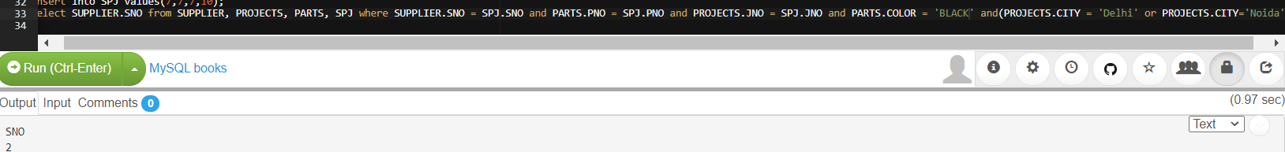

**

**

**

**

**

**

**

**

**

**

**

**

**

**ASSIGNMENT 3**

**TABLE 3**

**Values Inserted:**

SQL QUERIES –

**

**

**

**

**

**

**

**

**

**

**

**

**

**

**

**

**

**

**

**

**PL-SQl**

**VIEWS**

